**Lab 24 - Wireless**

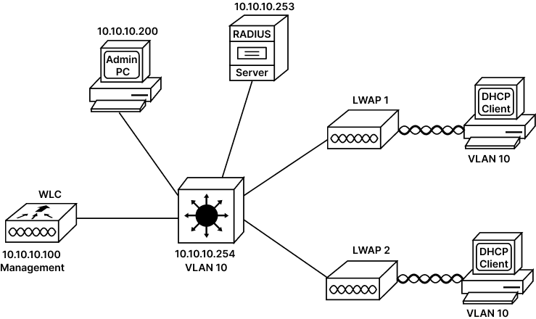

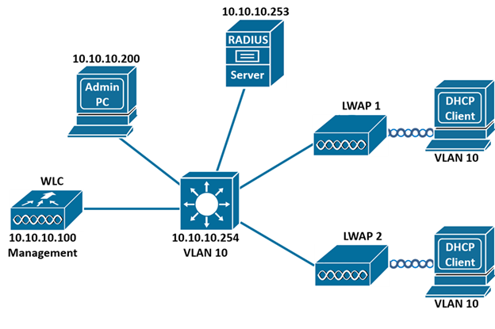

**Device Connectivity:**

| **DEVICE 1** | **PORT** | **DEVICE 2** | **PORT** | **VLAN** |
| --- | --- | --- | --- | --- |
| LWAP-1 | Gigabit Ethernet 0 | Switch-1 | Fast Ethernet 0/10 | VLAN 10 |
| LWAP-2 | Gigabit Ethernet 0 | Switch-1 | Fast Ethernet 0/20 | VLAN 10 |
| WLC-1 | Gigabit Ethernet 1 | Switch-1 | Gigabit Ethernet 0/1 | VLAN 10 |
| PC-1 | Fast Ethernet 0 | Switch-1 | Fast Ethernet 0/1 | VLAN 10 |
| Radius Server | Fast Ethernet 0 | Switch-1 | Fast Ethernet 0/2 | VLAN 10 |

**Task 1: Basic configuration of L3 Switch:**

As per our Lab Scenario and the device connectivity table, configure all connected switch ports as members of VLAN 10.

**Step 1: Access the console of switch and use following command to configure VLAN10 and assign VLAN port membership:**

SWITCH# config terminal

SWITCH# (config)# vlan 10

SWITCH# (config-vlan)# name WIRELESS

SWITCH# (config-vlan)# exit

SWITCH# (Config)# interface range fa0/1, fa0/2, fa0/10, fa0/20, gi0/1

SWITCH# (Config-if-range)# switchport mode access

SWITCH# (Config-if-range)# switchport access vlan 10

SWITCH# (Config-if-range)# end

As seen above, we have configured VLAN 10 and provided it with name WIRELESS and added all connected interfaces to VLAN 10. now Let us verify the VLAN configuration:

**Step 2: Verify the VLAN configuration using the following command:**

SWITCH# show vlan

VLAN Name Status Ports

---- ------------ ------- ------------------------------------

10 WIRELESS active Fa0/1, Fa0/2, Fa0/10, Fa0/20, Gig0/1

As seen above, VLAN 10 is active and its name is WIRELESS. We can also see that switch has assigned port Fa0/1, Fa0/2, Fa0/10, Fa0/20, and Gig0/1 membership to VLAN 10.

This switch being POE it can provide inline power to the LWAPP (Light Weight Access Points). So, let us check the power assignment for the devices:

**Step 3: Verify the Power granted for the PoE devices. Use the following command:**

SWITCH# show power inline

Available:370.0(w) Used:10.0(w) Remaining:360.0(w)

Interface Admin Oper Power Device Class Max

Fa0/10 auto on 5.0 Light Weight Access Point0 n/a 15.4

Fa0/20 auto on 5.0 Light Weight Access Point0 n/a 15.4

As seen above in the output switch has assigned a max of 15.4 watts for each LWAPP device but currently only total of 10 watts is used.

**Task 2: Configure DHCP Server on L3 Switch:**

Let us configure DHCP Server on L3 Switch and create pool for VLAN10.

**Step 1: Access the console of switch and use following command to configure DHCP Server and create IP Pool for VLAN 10. Use following command:**

SWITCH# config terminal

SWITCH# (config)# ip dhcp pool wireless

SWITCH# (dhcp-config)# network 10.10.10.0 255.255.255.0

SWITCH# (dhcp-config)# default-router 10.10.10.254

SWITCH# (dhcp-config)# option 43 ip 10.10.10.100

SWITCH# (dhcp-config)# exit

SWITCH# (config)# ip dhcp excluded-address 10.10.10.100

SWITCH# (config)# ip dhcp excluded-address 10.10.10.254

As seen above, we have configured a DHCP pool named Wireless. And assigned ip address range 10.10.10.0/24. The default-routers IP address was configured in the pools.

Light Weight Access Points (LWAP) would require Wireless LAN controllers (WLC) IP address to join it. We have enabled Option 43 as WLCs IP address is sent by DHCP server to the LWAP using this option. IP address of WLC and Switch are statically configured on the devices and hence these addresses are excluded from the pool.

Now Let us configure the Software Virtual Interface (SVI) for VLAN 10 on switch and assign it IP address 10.10.10.254 255.255.255.0:

**Step 2: Access the console of switch and use following command to configure SVI for VLAN 10 and assign IP address to this SVI. Use following command:**

SWITCH# config terminal

SWITCH# (config)# interface vlan 10

SWITCH# (config-if)# no shutdown

SWITCH# (config-if)# ip address 10.10.10.254 255.255.255.0

SWITCH# (config-if)# end

Now Let us verify our SVI configuration.

**Step 3: Access Console of Switch and Verify the SVI configuration and its status. Use the following command:**

SWITCH# show ip interface brief

Interface IP-Address OK? Method Status Protocol

FastEthernet0/1 unassigned YES unset up up

FastEthernet0/10 unassigned YES unset up up

FastEthernet0/20 unassigned YES unset up up

GigabitEthernet0/1 unassigned YES unset up up

Vlan10 10.10.10.254 YES manual up up

As seen above the output shows that SVI for VLAN 10 is created and IP address 10.10.10.254 is assigned to it. This SVI is UP.

**Task 3: Verify DHCP Server:**

Let us verify that DHCP Server is assigning IP addresses to ADMIN PC.

**Step 1: Click the ADMIN PC and inside ADMIN PC click Config.**

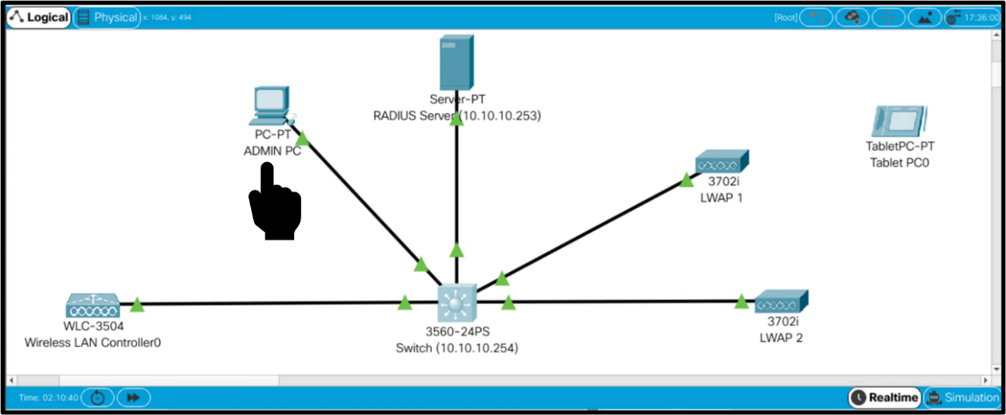

**Step 2: inside the ADMIN PC click Config and select FastEthernet0, inside IP Configuration section select DHCP as seen below: (If IP address is not assgined then select the static again and toggle back to DHCP)**

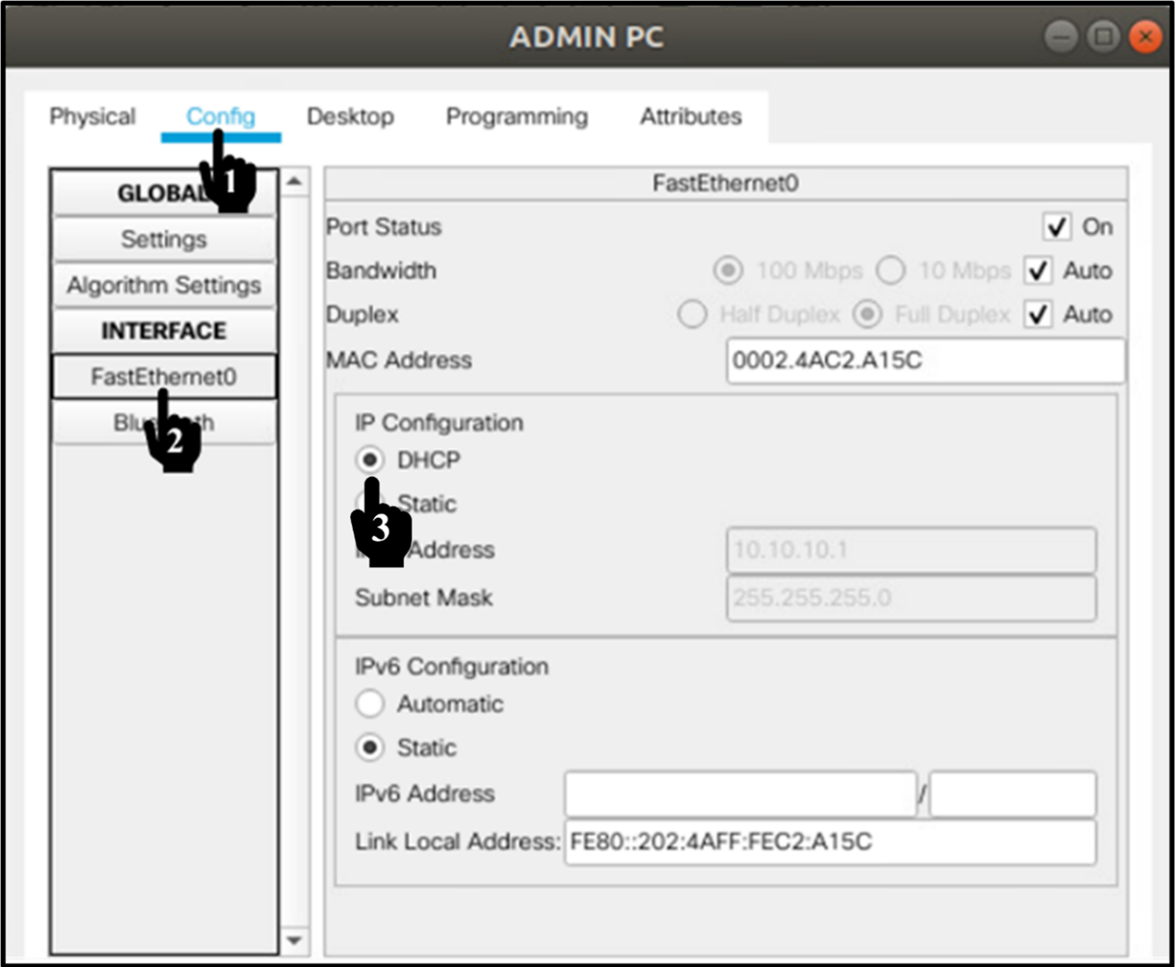

**Step 3: Now on command Prompt type ipconfig and ping the L3 Switch 10.10.10.254 as seen below:**

C:\> ipconfig

FastEthernet0 Connection:(default port)

Connection-specific DNS Suffix...:

Link-local IPv6 Address..........: FE80::202:4AFF:FFC2:A15C

IPv6 Address.....................: ::

IPv4 Address.....................: 10.10.10.1

Subnet Mask......................: 255.255.255.0

Default Gateway..................: ::

10.10.10.254

C:\> ping 10.10.10.254

Pinging 10.10.10.254 with 32 bytes of data:

Reply from 10.10.10.254: bytes=32 time<1ms TTL=255

Reply from 10.10.10.254: bytes=32 time<1ms TTL=255

Reply from 10.10.10.254: bytes=32 time<1ms TTL=255

Reply from 10.10.10.254: bytes=32 time<1ms TTL=255

Ping statistics for 10.10.10.254:

Packets: Sent = 4, Received = 4, Lost = 0 (0% loss),

Approximate round trip times in milli-seconds:

Minimum = 0ms, Maximum = 2ms, Average = 0ms

Now Let us verify that DHCP Server has assigned IP addresses to LWAP 1 and LWAP 2.

**Step 4: Click the LWAP 1 and inside LWAP 1 click Config:**

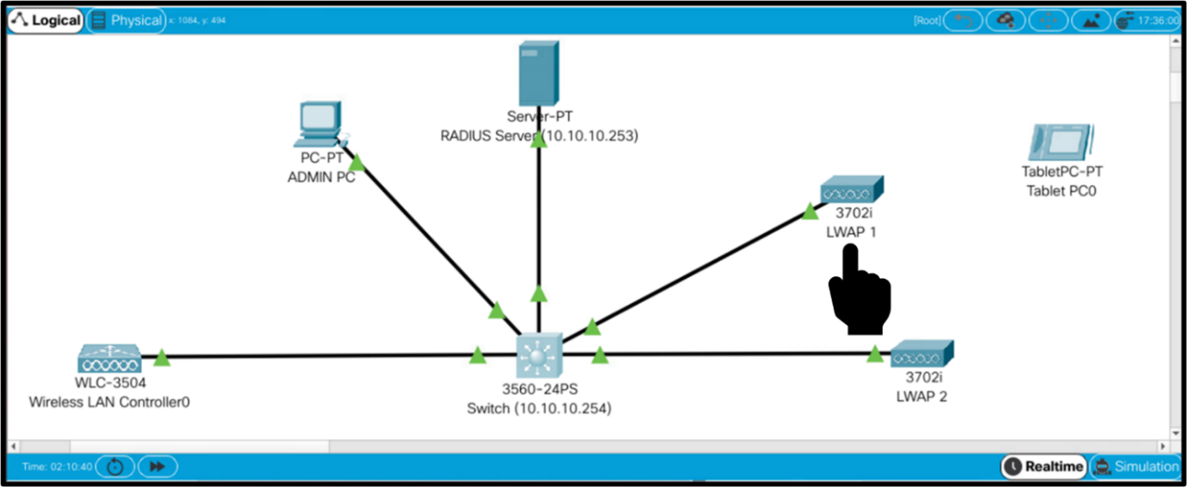

**Step 5: Inside the LWAP Screen as seen below Click the Config Tab then select the Interface Fast Ethernet0 and in the IP Configuration section Click DHCP. (If Ip address is not assigned then select options “static” and then toggle back to DHCP to renew IP Address) as seen below:**

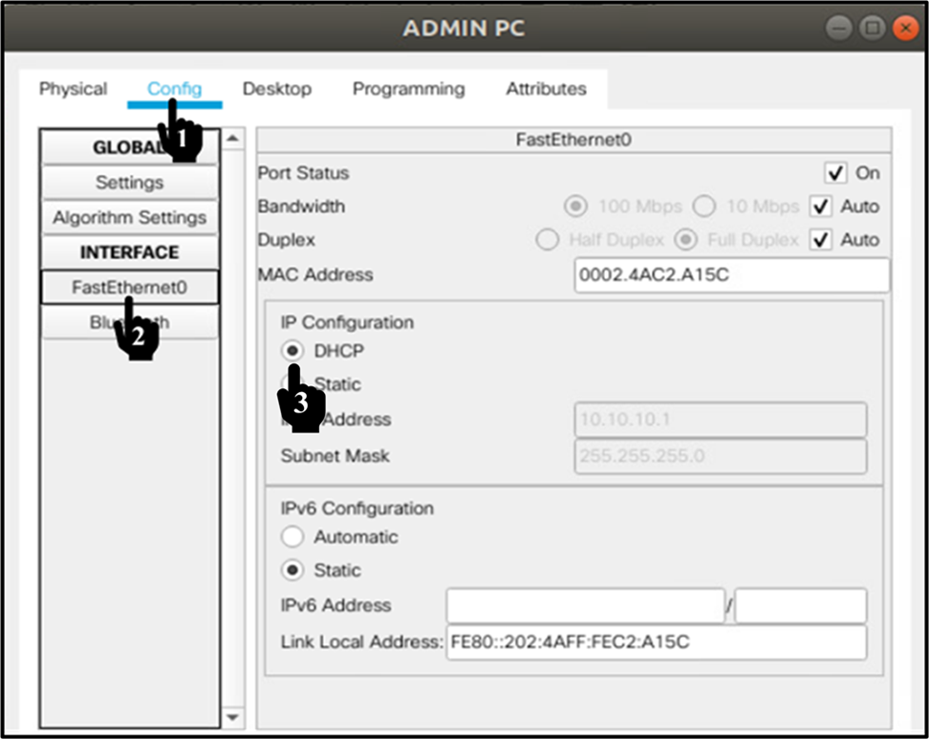

As seen above Light Weight Access Point 1 has now received IP address via DHCP, similarly we can verify that the LWAP 2 has also received an IP address from DHCP server.

**Task 4: Configure WLC and register LWAP:**

Let us configure IP address for WLC and check connectivity from Admin PC.

**Step 1: Click the WLC and inside WLC click Config:**

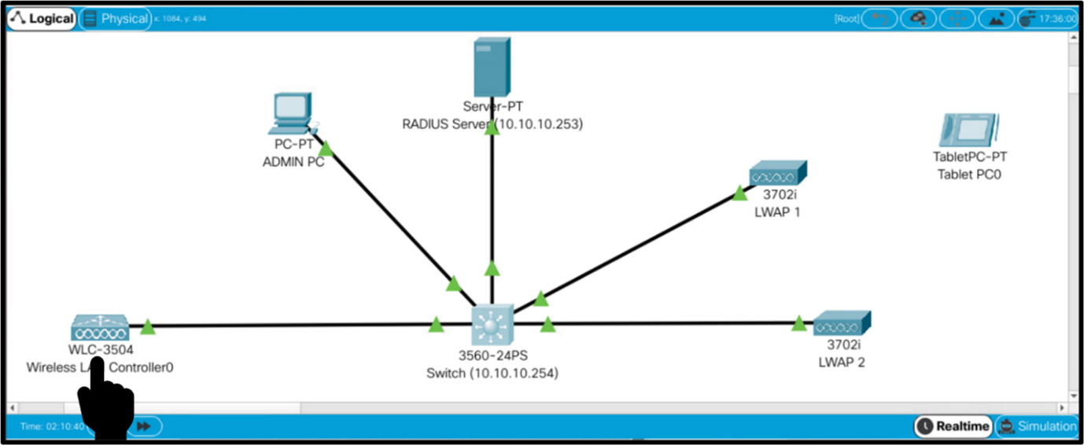

**Step 2: inside the WLC Screen click Config and select Management Option and inside Management option configure IP address and Default Gateway Address as seen below:**

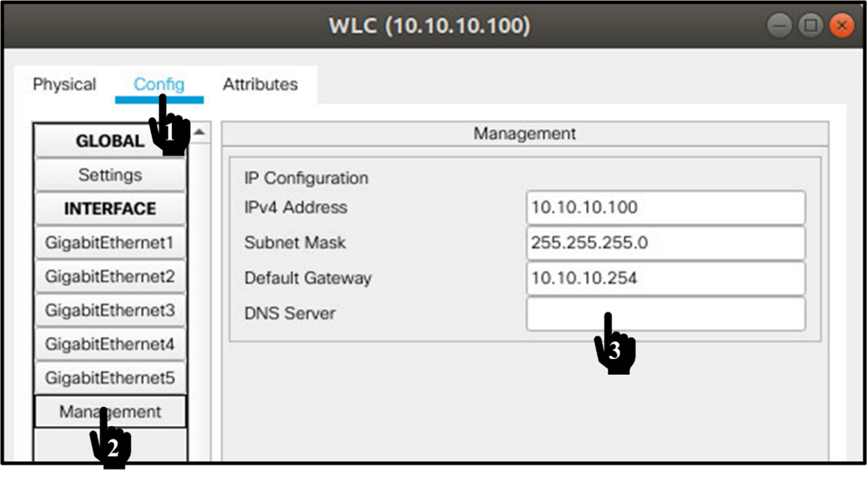

**Step 3: Verify that the Wireless LAN Controller can be accessed from ADMIN PC, exit from WLC, and click the ADMIN PC ICON as seen below:**

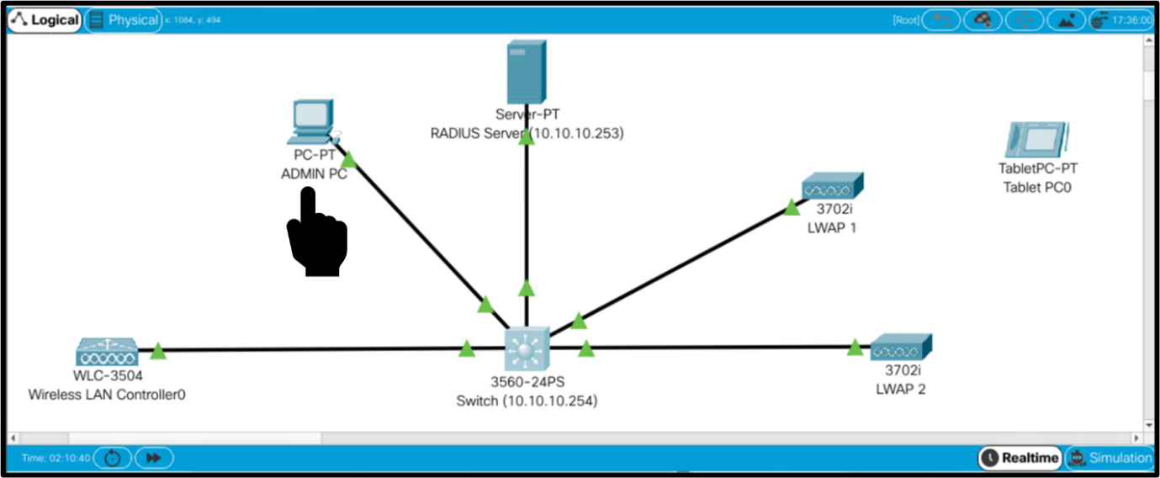

**Step 4: On the ADMIN PC screen click the Desktop Menu and then select the Browser option from there:**

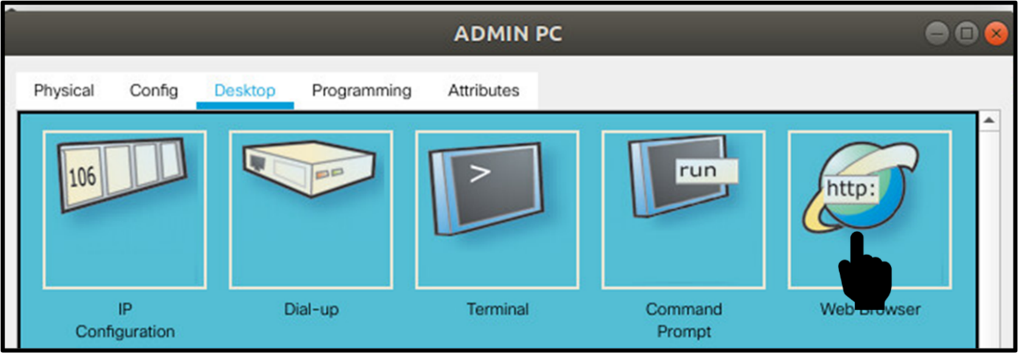

**Step 5: Access WLC using web browser of your desktop and type http://10.10.10.100.**

Type admin username= admin and admin password= Rst@1234 and click start.

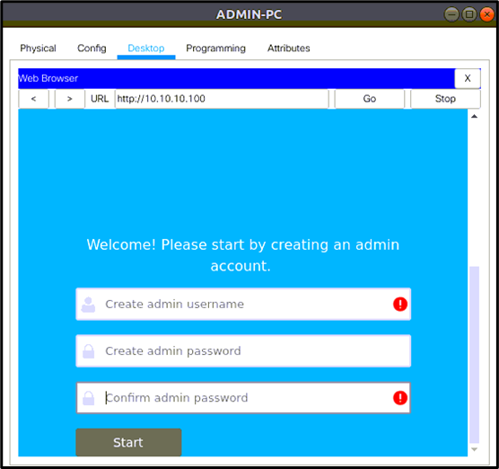

**Step 6: The following web page will get displayed, As mentioned below fill in the relevant inputs on this page and save it:**

System Name: RST-WLC.  
Management IP: 10.10.10.100  
Subnet Mask: 255.255.255.0  
default Gateway: 10.10.10.254.

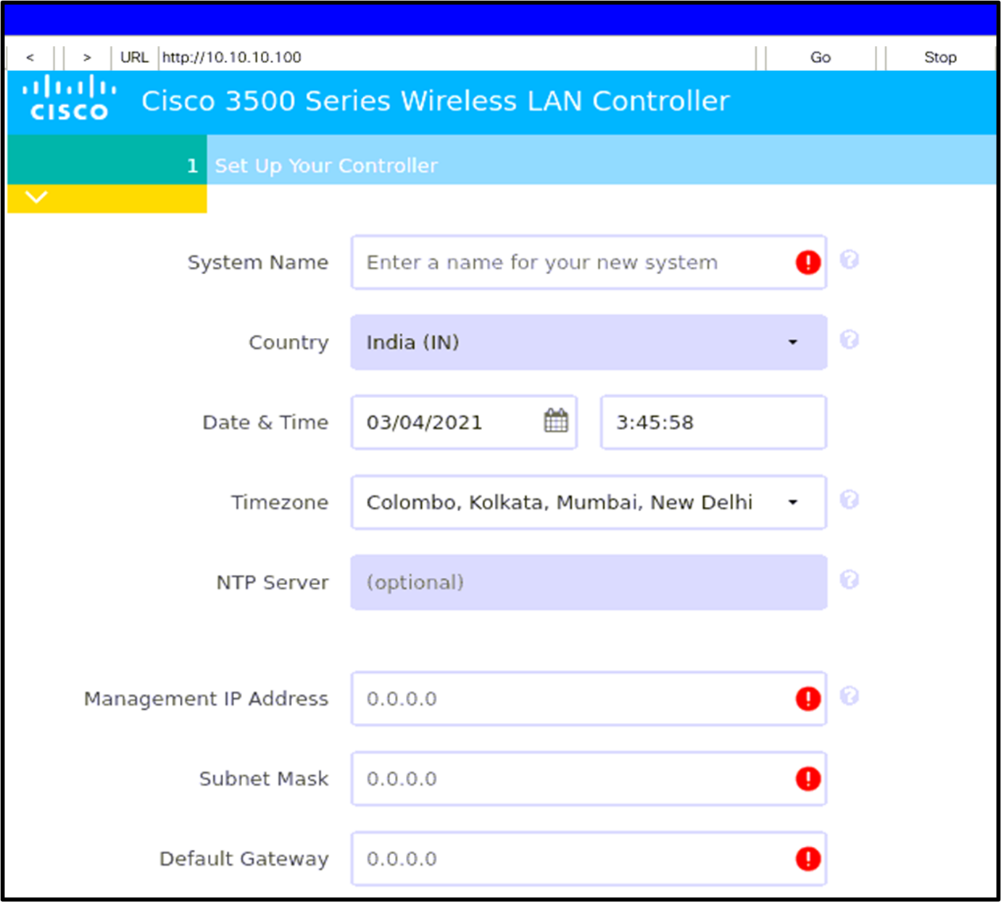

**Step 7: The Next step is to create a wireless network and fill in the following mentioned information:**

Select the Employee network slider to green.  
Enter the Network name as RST-EMPLOYEE.  
Select security as WPA2 Personal.  
Enter Passphrase as Rst@1234 and confirm again.  
Select VLAN as Management VLAN.  
Do not Select guest Network.  
Click next to Finish setup.

Just Ignore the RF Parameter Optimization and Apply

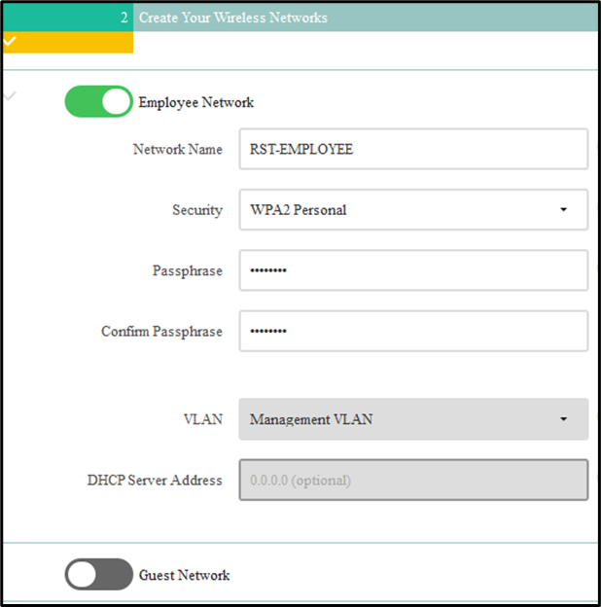

Just Ignore the RF Parameter Optimization and Apply

This will take some time to bring WLC up with new configuration. As this will take some time you can straight away go to next step.

**Step 8: To verify the Registration of LWAP on WLC. Enter the URL https://10.10.10.100. (Note http:// will no longer work).**

Enter the username and password as configured before (username=admin; password=Rst@1234).

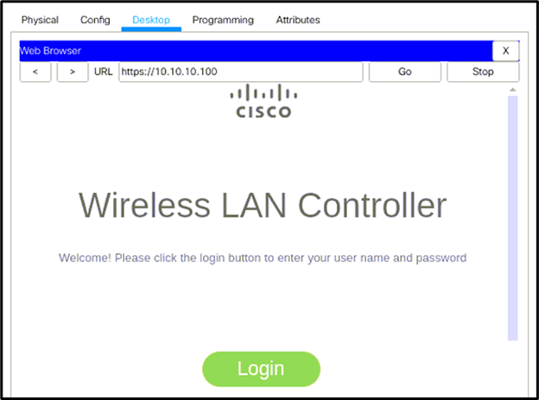

**Step 9: After login click WIRELESS Tab and verify the Registration of LWAP on WLC.**

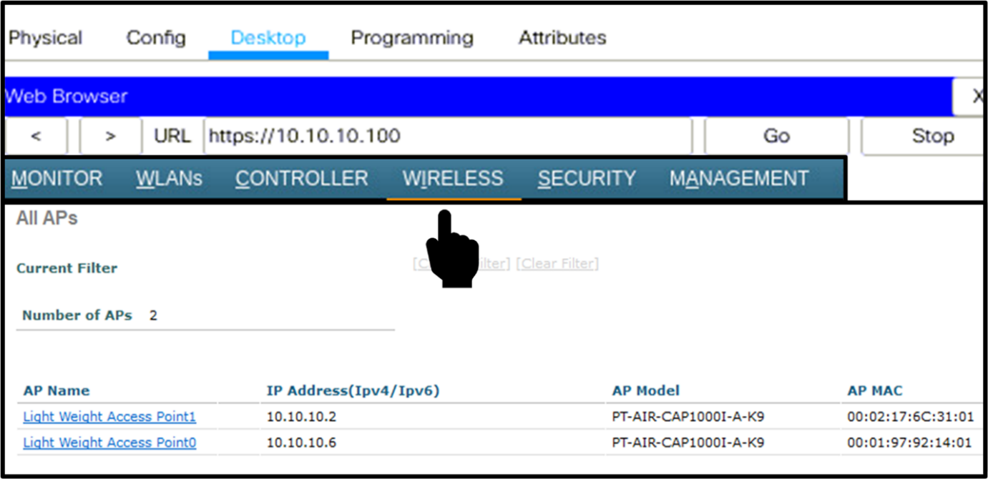

**Task 5: Creating SSID with Local Authentication:**

Let us create SSID on WLC using following command:

**Step 1: Access the WLC from ADMIN Desktop and authenticate using credentials. Click on WLANS tab. And remove all previously configured WLANs as seen below.**

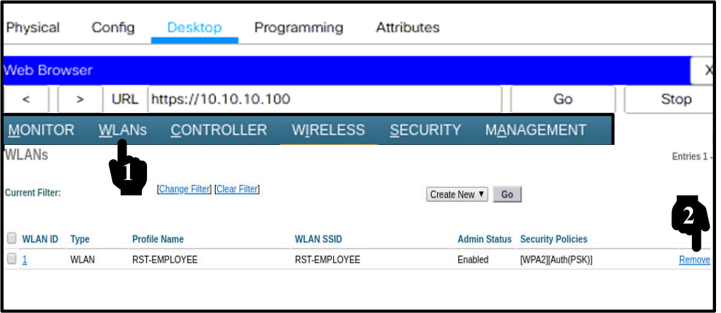

**Step 2: Select Create New from the drop-down list and click GO as seen below:**

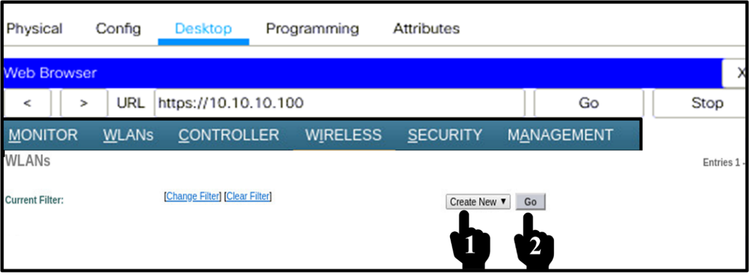

**Step 3: Select the type as WLANS. Fill in the Profile name and SSID as RST-EMPLOYEE. Select first available ID and Click apply button as seen below:**

Note: If required you may have to set admin status as enabled

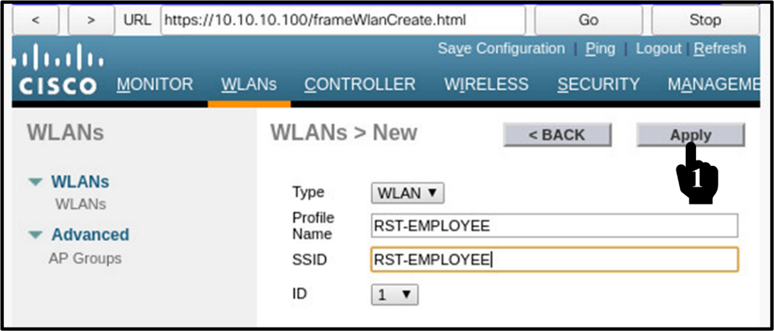

**Step 4: Apply will open the below screen here set the admin status as enabled and then click the security Tab, as seen below:**

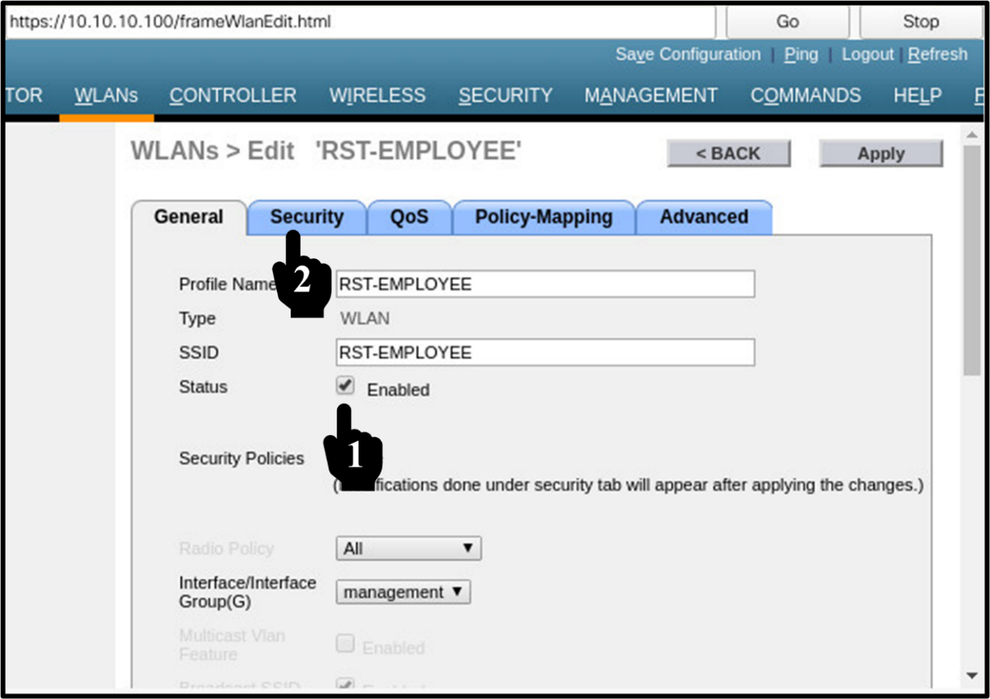

**Step 5: On the security screen select Layer 2 Security. (Layer 3 is not functional). Select the WPA + WPA2 option. For WPA + WPA2 Parameters tick mark WPA2 policy and then select the AES encryption type. For Authentication Key Management we can select either 802.1x security for AAA based authentication or Pre-Shared Key (PSK) option. For PSK (same key for all to connect). In our lab we will select the PSK option. Type the Pre-shared key for authentication (Use key= Rst@1234). Apply configuration**

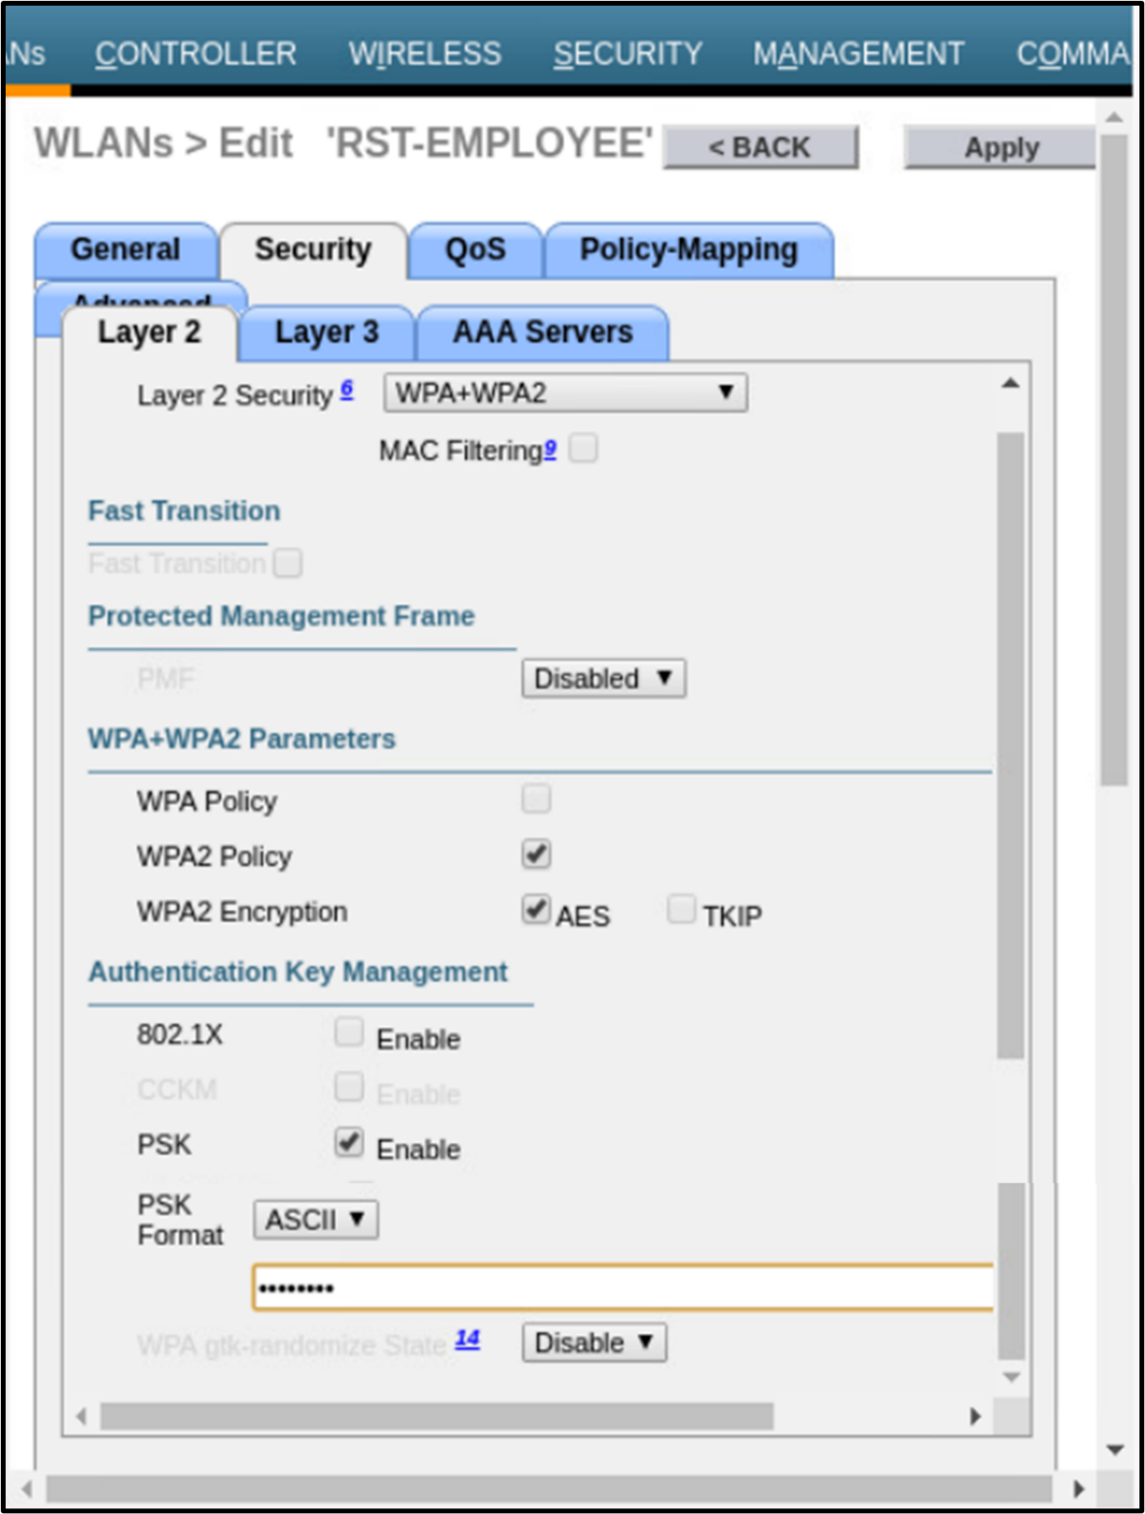

Exit the ADMIN PC and access the Tablet PC (DHCP Client). Configure Tablet PC, use SSID RST-EMPLOYEE and provide credentials to connect the network via Wireless Access Point:

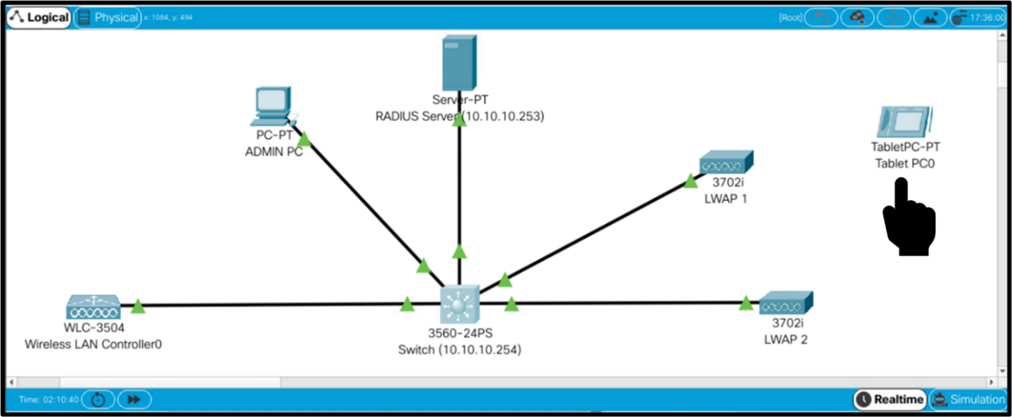

**Task 6: Join SSID using Local Authentication:**

**Step 1: On wireless Tablet PC, go to the Config tab and select the interface as wireless. Set the SSID as RST-EMPLOYEE. Select the Authentication options as WPA2-PSK and enter the Passphrase as Rst@1234 as seen below:**

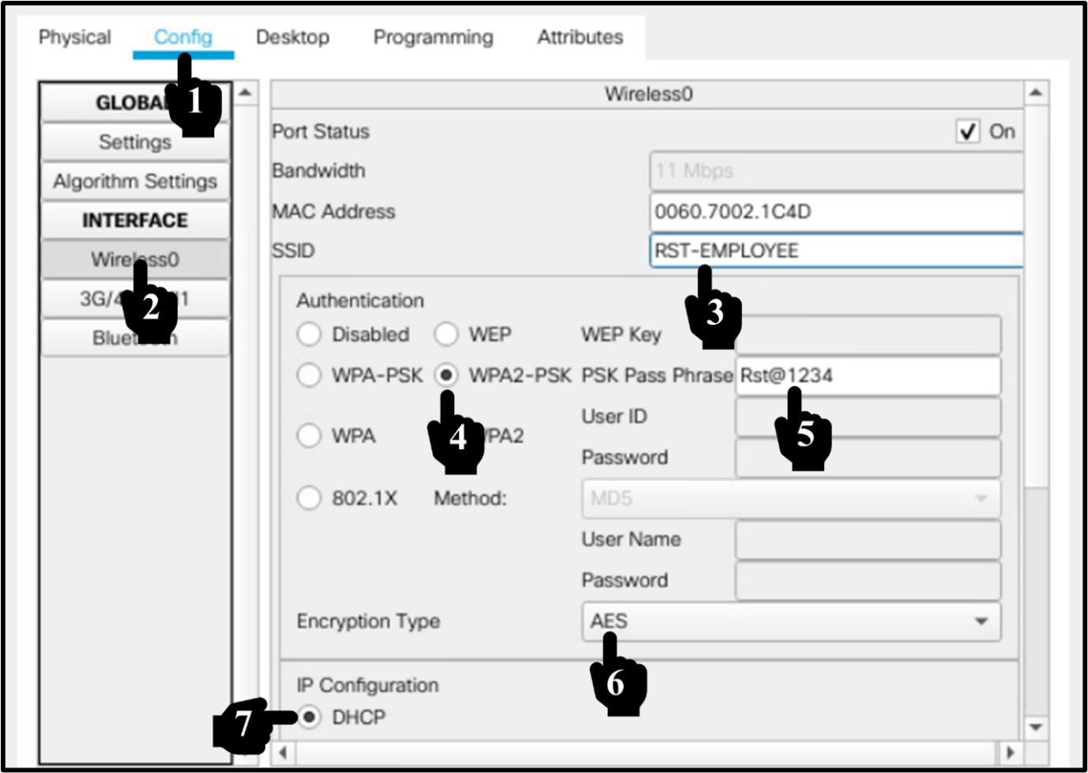

**Step 2: Exit the wireless Tablet PC, now you will see the Tablet got connected to LWAP.**

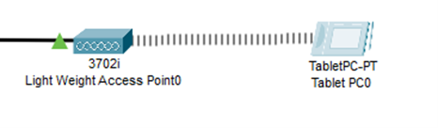

**Task 7: Register a AAA server to WLC:**

Configure AAA server and register it to WLC. Click the Server Icon as seen below:

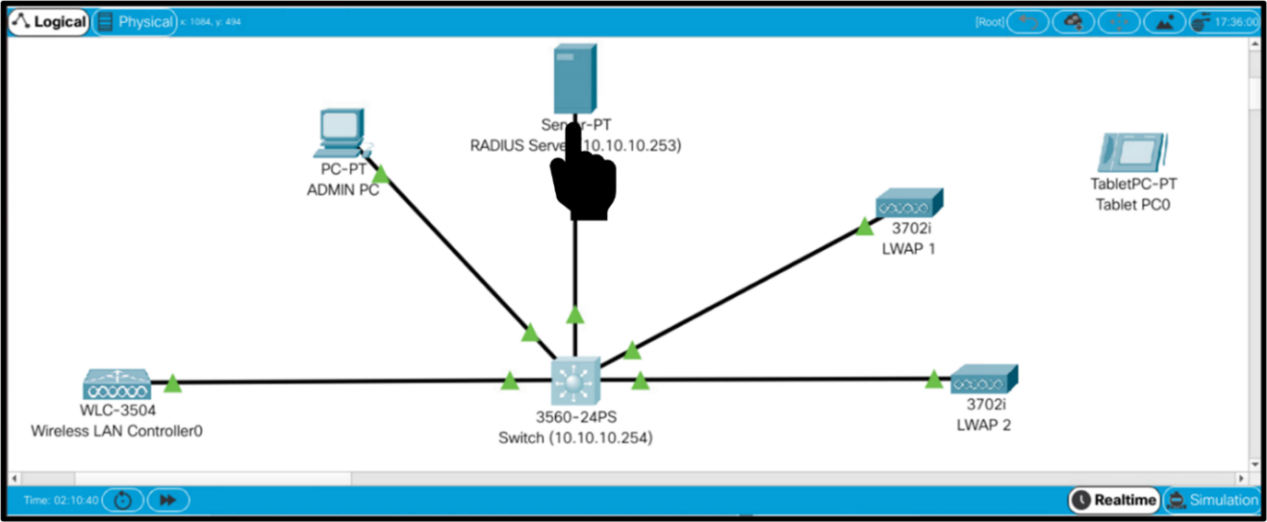

**Step 1: On the server screen click the configs tab and select FastEthernet0. Configure Static IP address of 10.10.10.253. Now Go to the Services tab as seen below:**

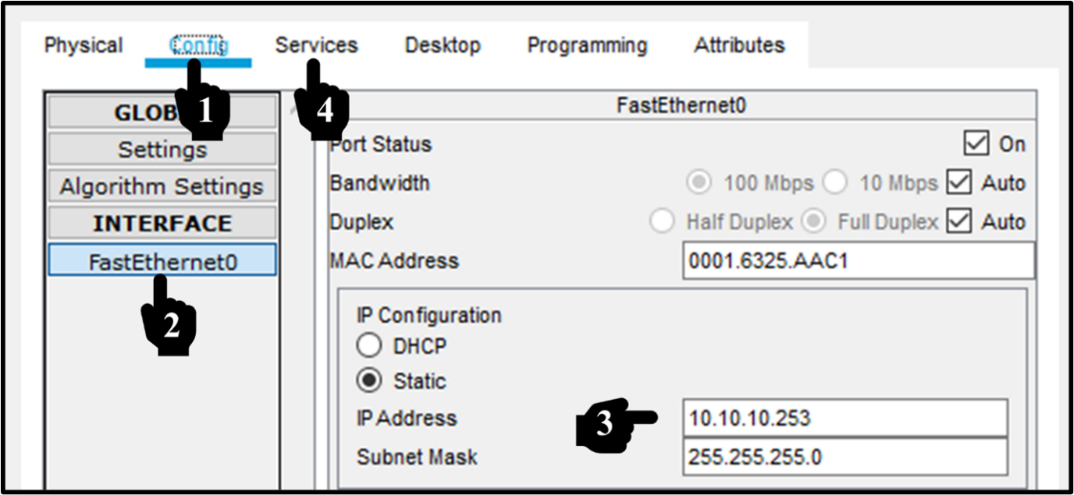

**Step 2: On the Services screen, In the network configuration, fill in Client name as RST-WLC, Client IP as 10.10.10.100 and the secret as Rst@1234. Leave the server type as Radius. Click ADD.**

We also need to create a user. Setup username as rstforum and Password as Rst@1234. Click Add

Select Radius Port as 1812 and Turn the AAA service “on” as seen below:

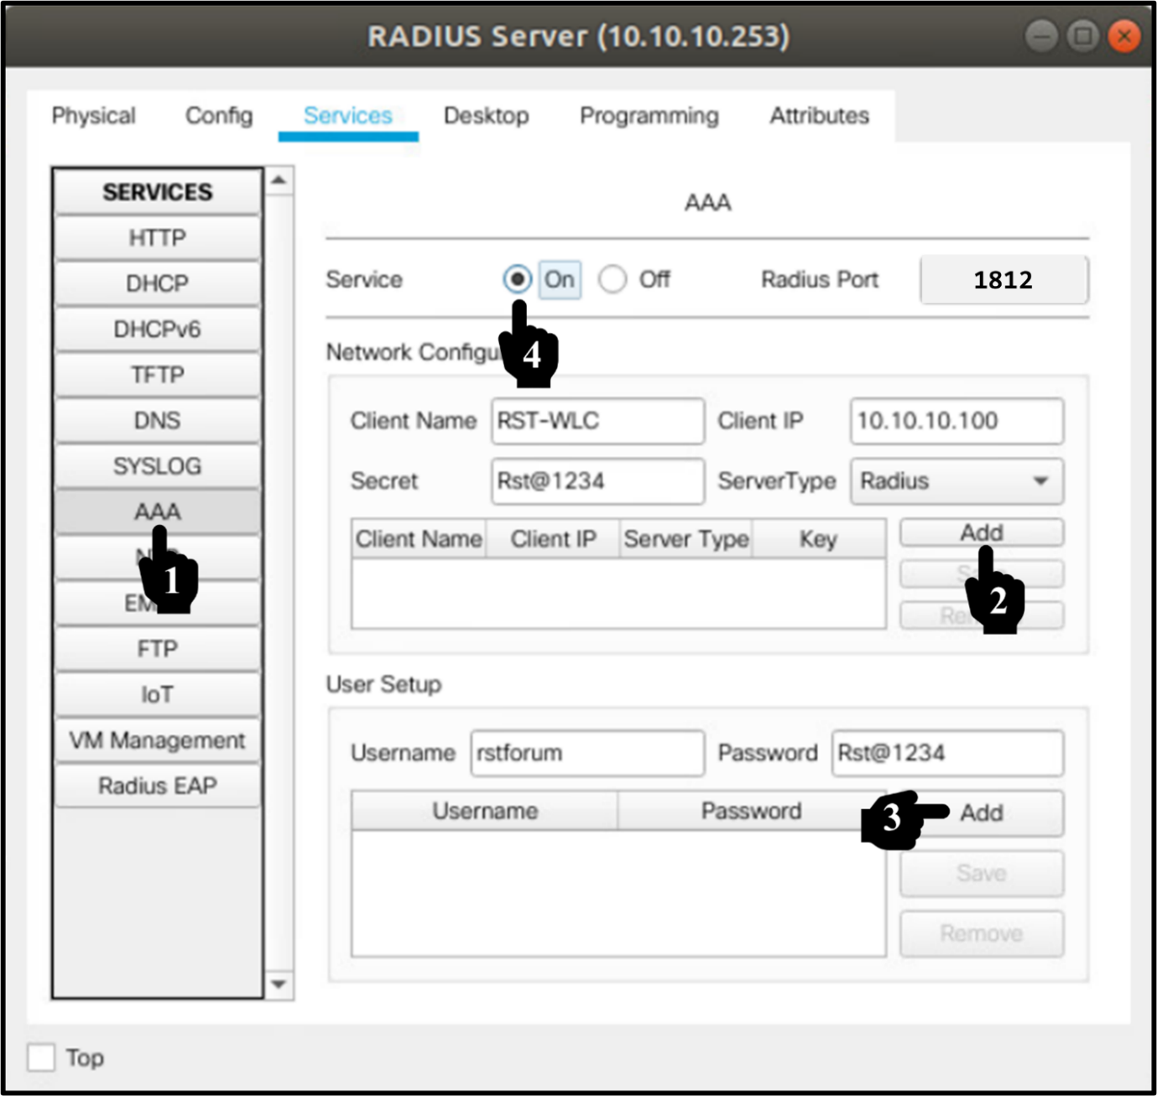

**Step 3: Now exit the Radius Server screen and go to ADMIN PC to take web access of WLC as seen below:**

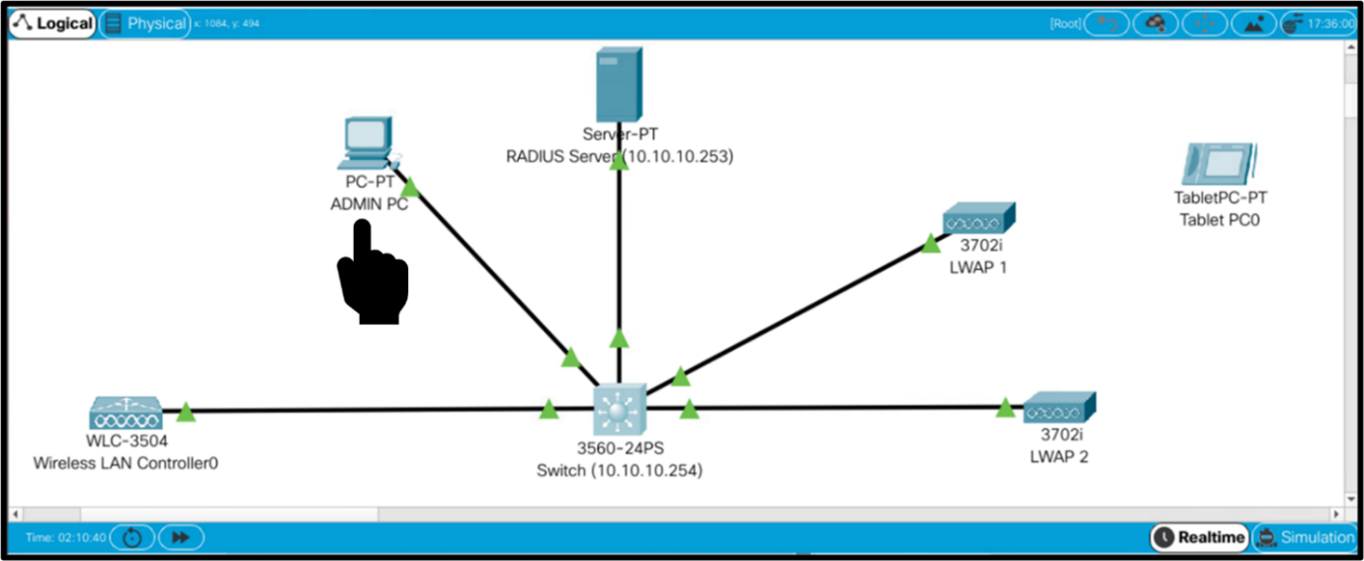

**Step 4: On the ADMIN PC screen click the Desktop Menu and then select the Browser option from there:**

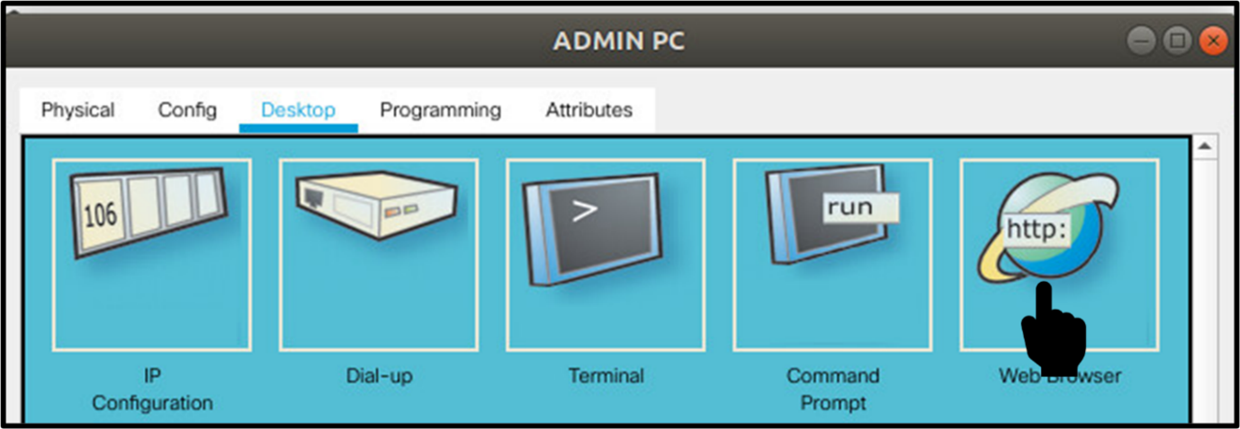

**Step 5: Access WLC using web browser of your desktop and type https://10.10.10.100.**

Type admin username= admin and admin password= Rst@1234 and click start.



**Step 6: After login go to the Security tab and select Radius Authentication in the left column then select New as seen below:**

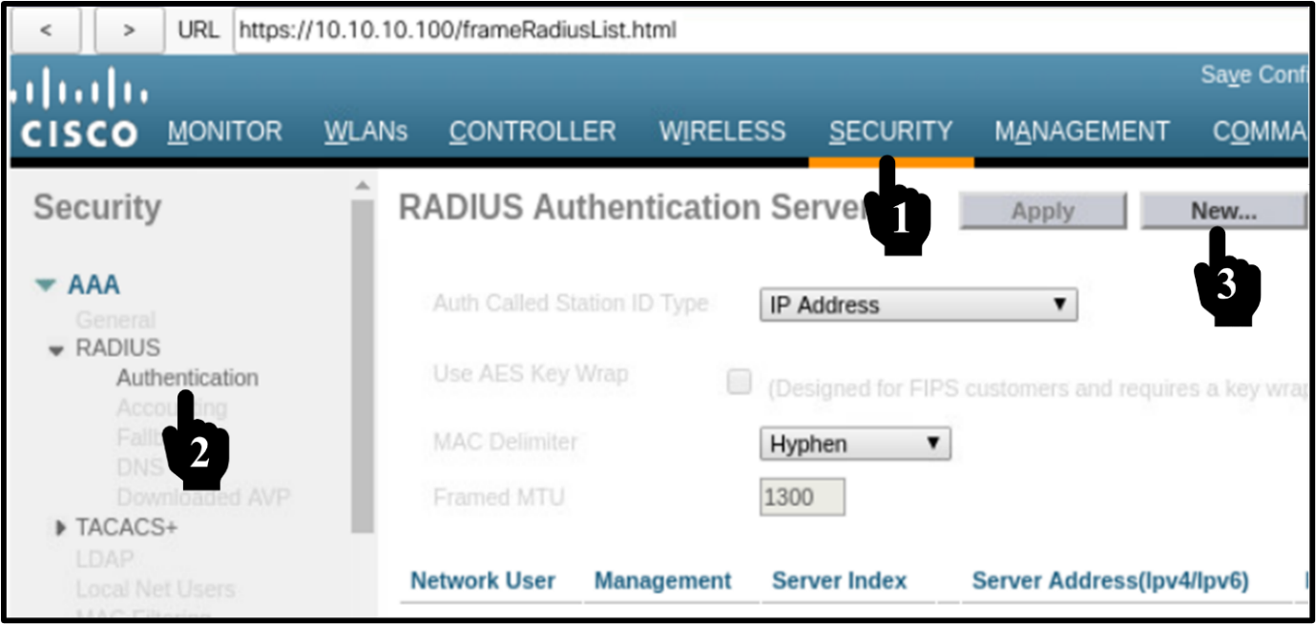

**Step 7: On this screen enter the WLC Server IP address and server credentials as seen below:**

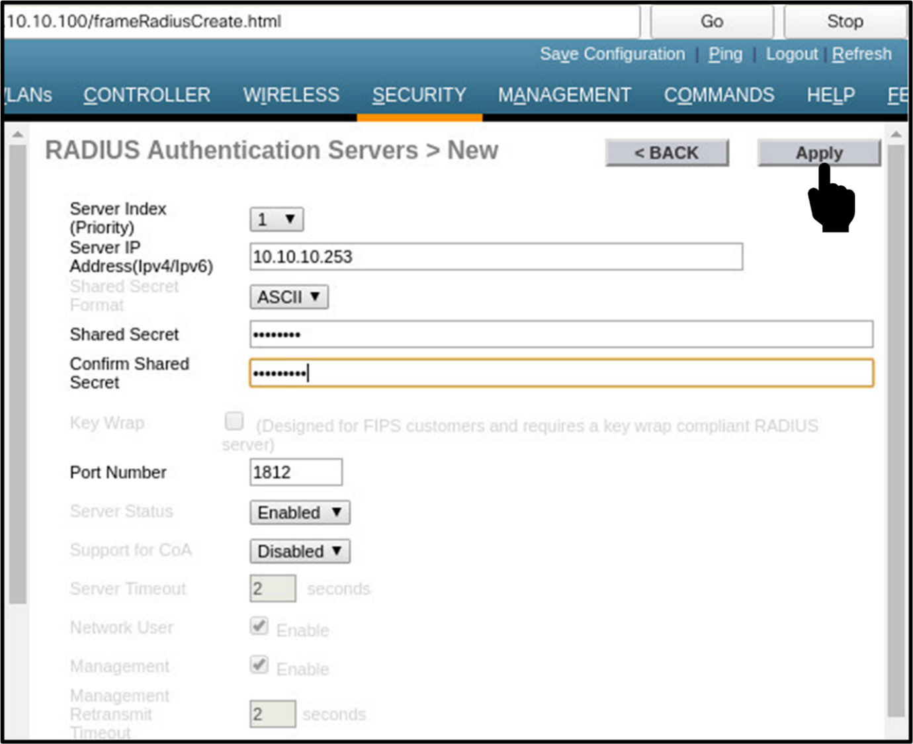

**Step 8: Once you apply the following screen will be displayed, it is showing that the server has been successfully configured for AAA as seen below:**

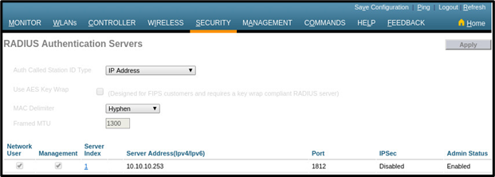

**Step 9: Now click WLANs Tab and in there select Create New and press GO to configure additional Profile name and SSID as seen below:**

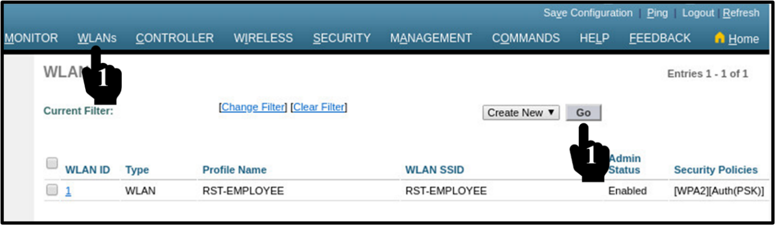

**Step 10: Now add new Profile name and SSID as RST-STUDENT and click apply as seen below:**

Note select ID as default chosen by system:

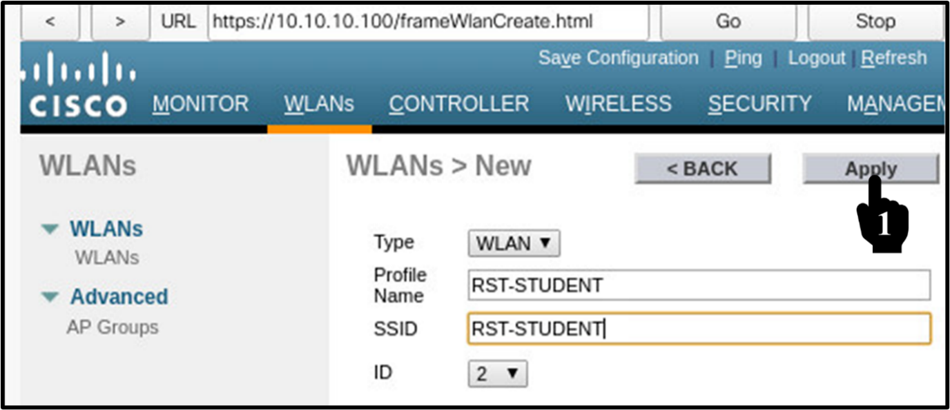

**Step 11: After Applying the config following screen will be displayed. On this screen select enabled and click apply as seen below:**

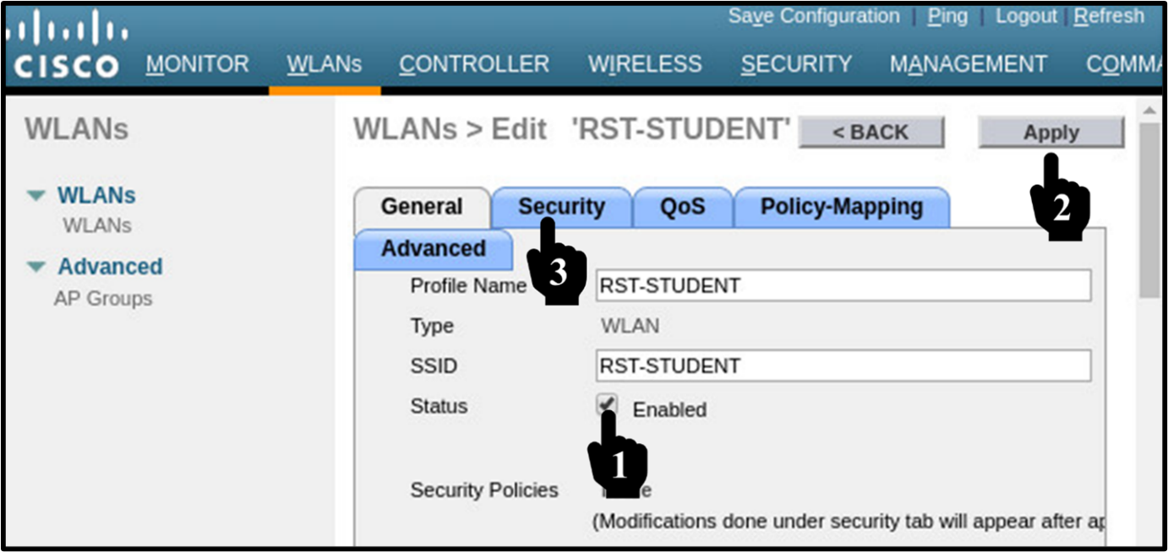

**Step 12: In the Security Tab go to Layer 2 security and select the Layer 2 security as WPA+WPA2. In the WPA2 policy select the Encryption as TKIP and key management as 802.1x, Click on Apply as seen below:**

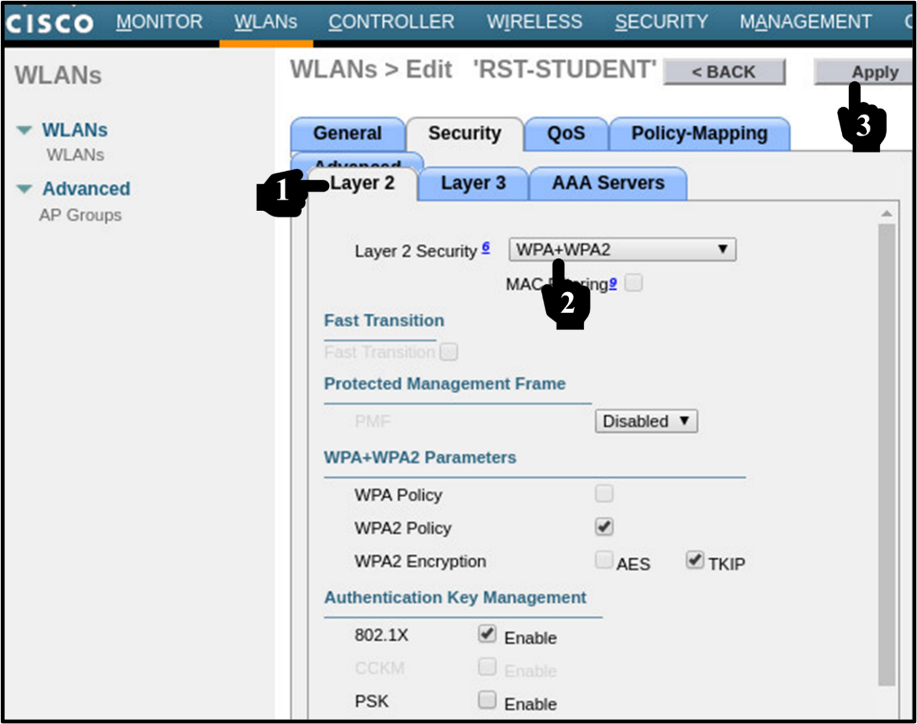

**Step 13: Now select Tab AAA Server option, Select the server as 10.10.10.253 and apply as seen below:**

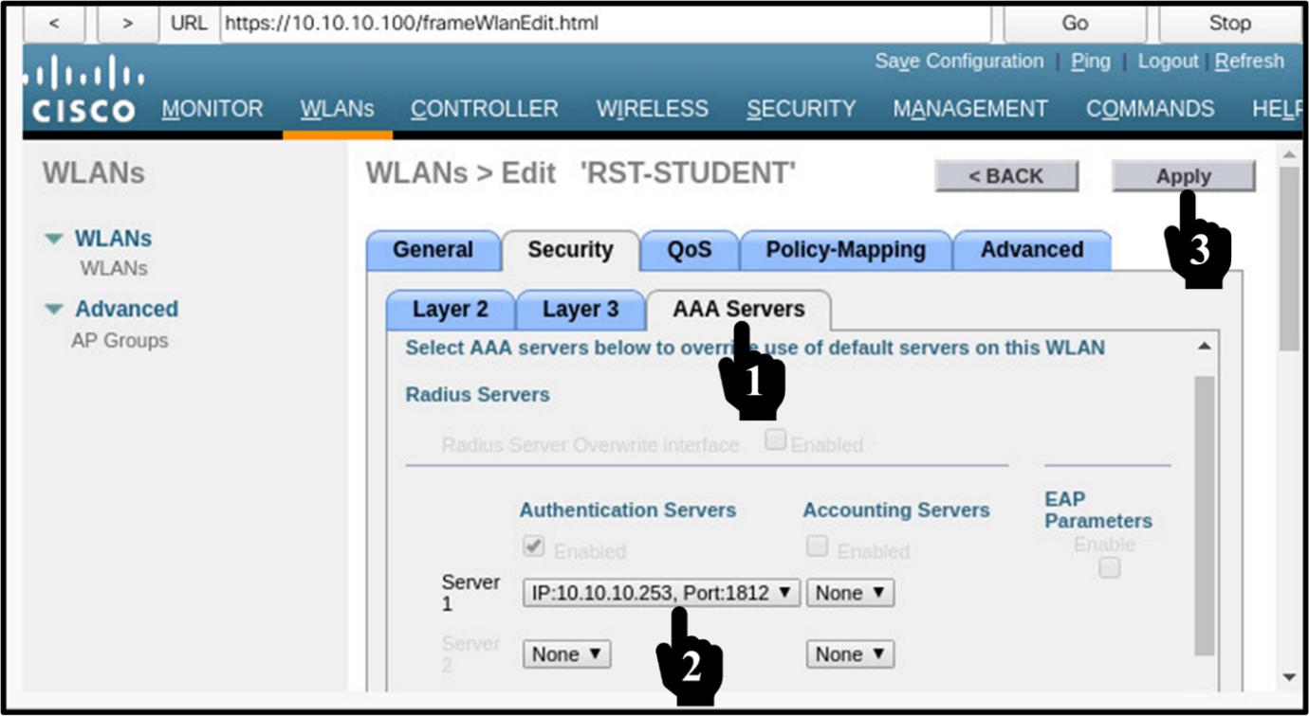

**Task 8: Join SSID using AAA Authentication:**

Exit the ADMIN PC and access the Tablet PC (DHCP Client) as seen below:

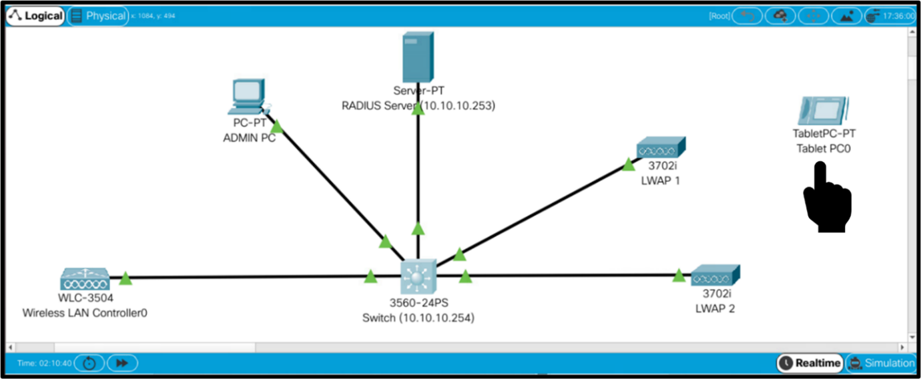

**Step 1: On wireless Tablet PC, go Config tab and select the interface as wireless. Set the SSID as RST-STUDENT. Select the Authentication options as WPA2. insert the user-id as rstforum and the password Rst@1234, select TKIP as seen below:**

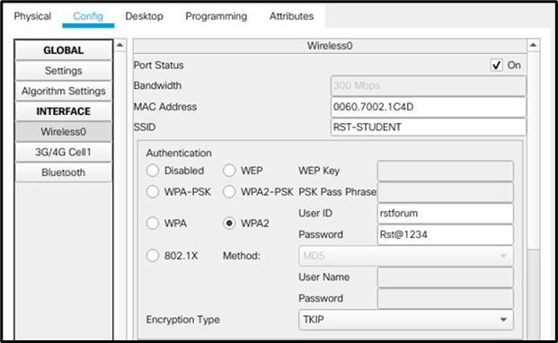

**Step 2: Exit the wireless Tablet PC, now you will see the Tablet got connected to LWAP.**

